How to Build a Flight & Hotel Booking App in Dubai?
Focus Keyword: Flight & Hotel Booking App in Dubai
Meta Title: Build a Flight & Hotel Booking App in Dubai | Step-by-Step Guide
Meta Description: Learn how to build a powerful flight & hotel booking app in Dubai with key features, tech stack, and development steps for travel startups.
Feature Image:


Many travel businesses struggle with digital booking systems today. Dubai users expect fast bookings and smooth payments. I faced similar issues while consulting travel startups earlier. They wanted growth but lacked proper mobile platforms. A booking app solves customer trust and revenue problems. It also reduces manual workload and booking errors. Dubai market demands secure and localized solutions. Users prefer apps over websites for quick travel plans. A reliable app improves brand authority instantly. This guide explains building a complete booking solution. You will learn planning, development, and launch steps.

Understanding Dubai Travel Market Needs
Local users compare prices before confirming bookings. Tourists demand multilingual support within apps. Dubai market values trust and secure transactions. Regulatory rules affect travel platforms strongly. Data privacy laws guide app data handling. Seasonal demand impacts booking app performance. Apps must support peak traffic periods smoothly. A local App Developer Dubai understands these patterns well. For example, a tourism app added Arabic support. User retention increased within two months. Market research shapes successful booking applications. Ignoring user behavior causes early app failure.

Choosing the Right Booking App Features
I helped teams prioritize features through real usage data. Essential features define booking app success. Users need search filters and clear pricing. Real time availability improves booking confidence. Push notifications increase repeat bookings. Saved traveler profiles speed future reservations. Admin dashboards help manage inventory easily. A Freelance App Developer Dubai often guides feature selection. For example, one client removed complex options. Bookings increased due to simplicity. Feature overload confuses first time users. Focus on travel convenience always. Smart features reduce customer support issues.

Flight Booking System Architecture
Flight systems need strong backend logic. API connections fetch airline data instantly. Caching improves search speed significantly. Fare rules require accurate handling. Error handling prevents booking failures. A Mobile App Developer Dubai builds scalable structures. One airline integration reduced load time. Users completed bookings faster. Secure token-based APIs protect data. Flight modules need constant monitoring. Downtime directly impacts revenue. Strong architecture ensures long term stability.
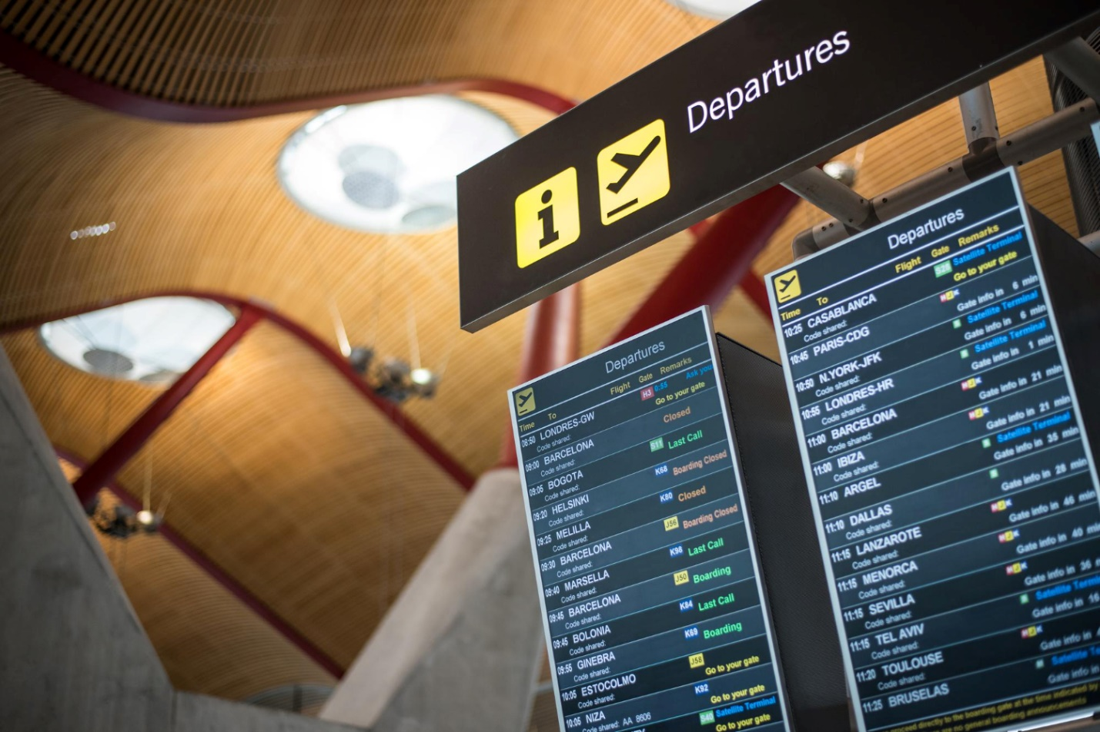

Hotel Booking Integration Strategy
Hotel modules differ from flight systems. Room availability changes frequently. Pricing varies based on demand. I integrated hotel systems across multiple regions before. Syncing inventory avoids overbooking issues. Images and descriptions influence user decisions. A Mobile App Development Dubai team ensures smooth syncing. One project connected global hotel suppliers. Booking errors dropped sharply. Hotel APIs require regular updates. Testing prevents mismatched room data. Reliable integration builds user trust quickly. Accuracy drives repeat bookings.
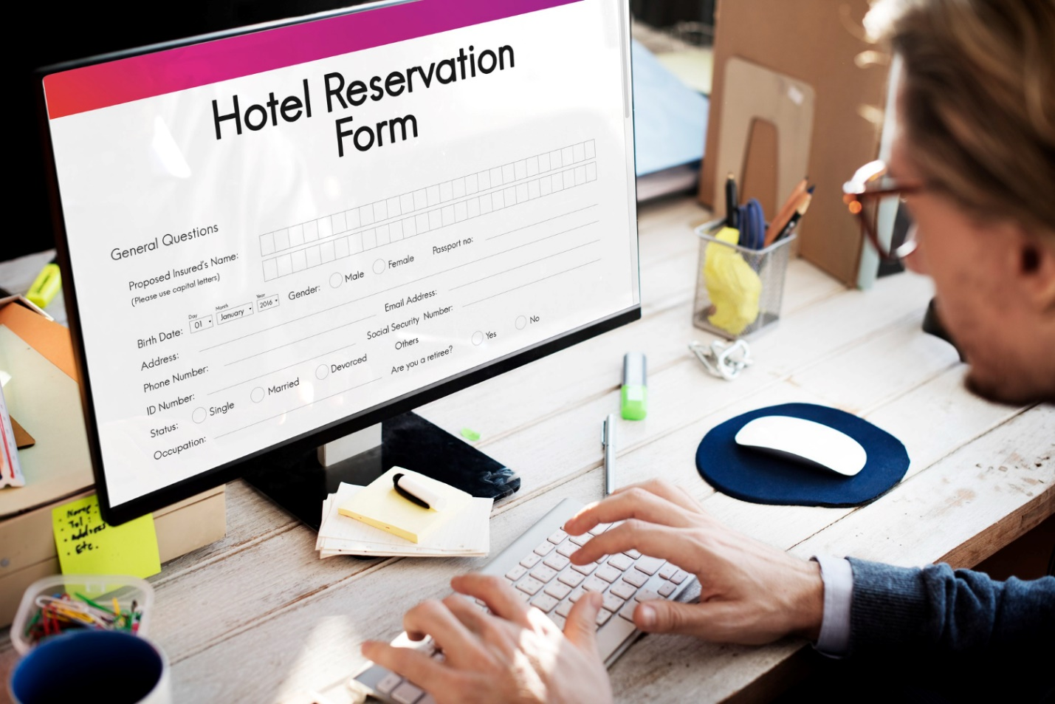

Payment Gateways and Local Compliance
Dubai requires secure payment standards. Apps must support cards and wallets. Local gateways improve transaction success. Currency conversion must stay accurate. PCI compliance protects customer data. A Freelance Mobile App Development Dubai expert ensures safety. One app added local wallet support. Checkout abandonment reduced noticeably. Fraud prevention tools are essential. Payment failures damage brand credibility. Compliance avoids legal penalties. Secure payments increase customer confidence.

UI UX Design for Travel Apps
I improved booking flows through user testing sessions. Design impacts booking completion rates directly. Simple layouts guide users smoothly. Clear buttons reduce confusion. Color consistency builds brand recognition. Fast loading screens retain users. Dubai users prefer premium visual styles. I applied design insights from twenty-five years. One redesign improved session duration. Users explored more destinations. UX testing reveals hidden issues. Accessibility increases app reach. Good design supports business growth.

Backend Development and API Management
Backend controls app reliability. Servers must handle high booking loads. API management ensures smooth data flow. I managed backend systems for travel platforms earlier. Security layers protect sensitive information. Cloud scaling supports seasonal demand spikes. Proper logging helps error tracking. One backend upgrade improved response time. Admins monitored bookings efficiently. Strong backend reduces downtime risks. APIs need version control always. Maintenance keeps systems stable. Backend strength defines app performance.

Launch Strategy and App Scalability
Soft launches identify early bugs. User feedback improves final releases. I planned app launches with phased rollouts. Marketing boosts initial downloads. App store optimization increases visibility. Scalability planning prevents crashes. Cloud resources support growth. Analytics track user behavior. One app scaled during holiday traffic. No performance issues appeared. Continuous updates keep apps relevant. Growth planning ensures long term success. Launch strategy impacts first impressions.

Conclusion
Building a booking app requires clear planning. Dubai market rewards quality and trust. Experienced guidance reduces costly mistakes. A professional approach ensures stable growth. Travel apps need strong features and security. Design and backend deserve equal focus. Start with user needs always. Partner with experts for better results. Contact Mistersaad today to build your travel platform.

FAQs
What is the app development timeline?
Most projects take four to six months.
Is maintenance required?
Yes updates ensure security and performance.
Can features expand later?
Yes scalable architecture supports growth.